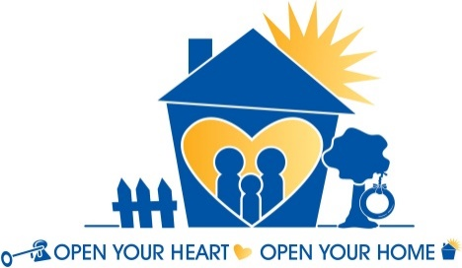
Fresno County Department
of Social Services
Resource Family Orientation Schedule

Dates of Orientation | Session #1 | Session #2
Monday, November 5, 2018 | 9:00am - 10:30am | 11:00am - 12:30pm
Monday, November 19, 2018 | 5:30pm - 7:00pm | 7:30pm - 9:00pm
Monday, December 10, 2018 | 9:00am - 10:30am | 11:00am - 12:30pm
Monday, January 14, 2019 | 9:00am - 10:30am | 11:00am - 12:30pm
Monday, January 28, 2019 | 5:30pm - 7:00pm | 7:30pm - 9:00pm
Monday, February 11, 2019 | 9:00am - 10:30am | 11:00am - 12:30pm
Monday, February 25, 2019 | 5:30pm - 7:00pm | 7:30pm - 9:00pm
Monday, March 11, 2019 | 9:00am - 10:30am | 11:00am - 12:30pm
Monday, March 25, 2019 | 5:30pm - 7:00pm | 7:30pm - 9:00pm
Monday, April 8, 2019 | 9:00am - 10:30am | 11:00am - 12:30pm
Monday, April 22, 2019 | 5:30pm - 7:00pm | 7:30pm - 9:00pm
Monday, May13 , 2019 | 9:00am - 10:30am | 11:00am - 12:30pm
__Monday, May 20, 2019-- | -5:30pm ~7:00pm- | -7:30pm - 9:00pm-
Monday, June 10, 2019 | 9:00am - 10:30am | 11:00am - 12:30pm
Monday, June 24, 2019 | 5:30pm - 7:00pm | 7:30pm - 9:00pm
Monday, July 8, 2019 | 9:00am - 10:30am | 11:00am - 12:30pm
Monday, July 22, 2019 | 5:30pm - 7:00pm | 7:30pm - 9:00pm
Monday, August 12, 2019 | 9:00am - 10:30am | 11:00am - 12:30pm
Monday, August 26, 2019 | 5:30pm - 7:00pm | 7:30pm - 9:00pm
Monday, September 9, 2019 | 9:00am - 10:30am | 11:00am - 12:30pm
Monday, September 23, 2019 | 5:30pm - 7:00pm | 7:30pm - 9:00pm
Monday, October 14, 2019 | 9:00am - 10:30am | 11:00am - 12:30pm
Monday, October 28, 2019 | 5:30pm - 7:00pm | 7:30pm - 9:00pm
Monday, November 4, 2019 | 9:00am ~ 10:30am | 11:00am - 12:30pm
Monday, November 25, 2019 | 5:30pm - 7:00pm | 7:30pm - 9:00pm
Monday, December 9, 2019 | 9:00am - 10:30am | 11:00am - 12:30pm

Become a Resource Parent today!
If you are interested in learning more, please come to one of our informational orientations.

This orientation is a requirement for the Resource Family Approval process.
Please make arrangements to attend only one session. The Orientation is for adults only.
No appointment is necessary.

Orientation Location:
West Fresno Regional Center
142 E. California Avenue, Fresno, CA 93706
(On the South West corner of California & Walnut)
English Orientation: Room #207 / Spanish Orientation: Room #214

Questions?

Call the Fresno County Resource Family Support unit at
1 (877) 533-KIDS (5437)
2011 Fresno St., Fresno, CA 93721

Please check our Websites at:
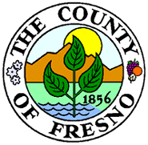
http://www.co.fresno.ca.us/DepartmentPage.aspx?id=47047
http://www.fresnoresourcefamilies.org
for more information and updates.

